

**PROJECT REPORT**

**WORK OF:**

**SYEDA AAMNA SHAHID-366216**

**MUHAMMAD AMMAR-368681**

**SUBMITTED TO**: Mr.AHSAN SADAAT

**BESE 12-B.**

**PROJECT OVERVIEW:**

The project was a program for a grocery store, that offers different items that are available on a regular grocery store.

The program works in a way that first, user has to create a profile/register and then he/she can access the store items.

The user will use the same credentials that he/she used upon registration, that holds their previous records of purchase basically, the purchase history.

Once logged in, the menu window pops up and different sections of store are displayed on the screen. User can select section of his choice e.g food and vegetables and can shop there.

The procedure for all sections is nearly the same.

Upon selecting a section, there is a dynamic search bar, you can directly click on submit to view the relevant inventory or type a keyword and press submit to view items against the keyword.

User can then purchase an items or more as per his choice and then can go back to menu section or can view cart where he can eliminate the selected item.

Finally, when user is done shopping, he can go to cart and click purchase to get the bill printed.

**OBJECTIVE:**

The major objective of this project was to facilitate the user as well as the owner.

The user can simply use the program rather than physically moving throughout the store and thus making shopping easy.

The second objective was to optimize the owners income/profit by making him invest more on the inventory rather than the physical structure of the store and the unnecessary bills e.g gas and electricity bills etc.

This concept of a virtual grocery store facilitates both the user and the owner of the store.

The key objective is the time saving factor of the store. User has no need to go all the way to the store and move searching for items of his choice and make purchases rather he can simply order from one place and save his time.

**LOGIN WINDOW:**

The login window consists of two text fields with labels **username** and **password**.

Below them is a checkbox for showing the password since password is coded in *.

Next, we have two buttons,

**Login** and **create new account.**

For a new user, he must create an account first and then he/ she can access the store.

Once created, login from login page and access menu page.

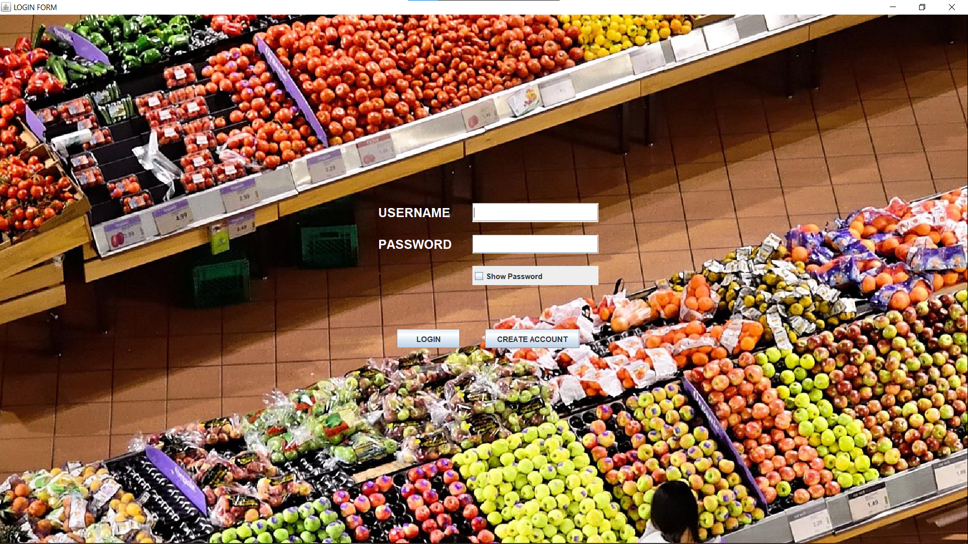

**CODE:**

Basic **GUI** components that are frequently used and their size and location parameters are common throughout the project.

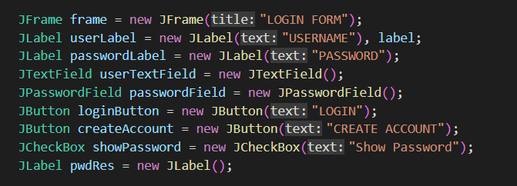

Logic of username and password verification is such that when provided, the **userfile** is checked for the provided credentials, if found, account Is logged in, otherwise, message **WRONG Password** is displayed.

**REGISTRATION PAGE:**

When you click on Create New Account, following window pops up.

Fill all the particulars and click submit.

The provided information appears in the right TextArea.

In case, you want to clear information, click reset.

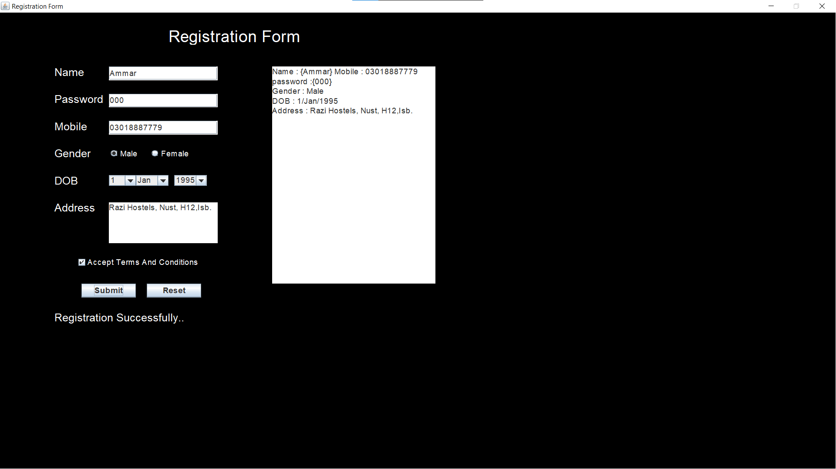

**GUI COMPONENTS FOR REGISTRATION FORM:**

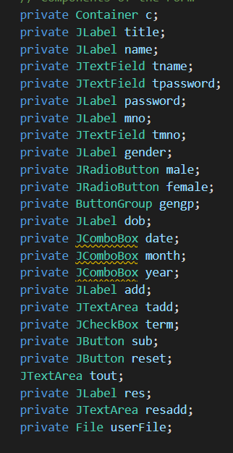

The information provided by user in the registration form is then thoroughly stored in data members **data, data1, data2, data3, data4** and then all of them are written in a file i.e. **userfile**.

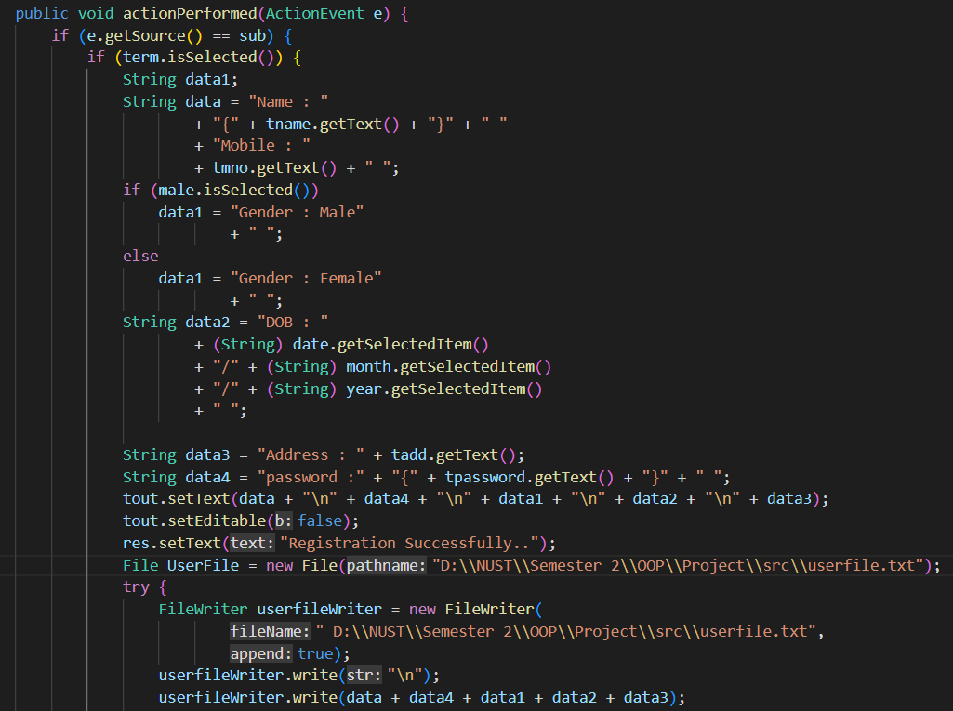

**MENU PAGE:**

After logging in, the following menu window appears.

The functionality of all menu options is the same.

For demonstration, we chose crockery section.

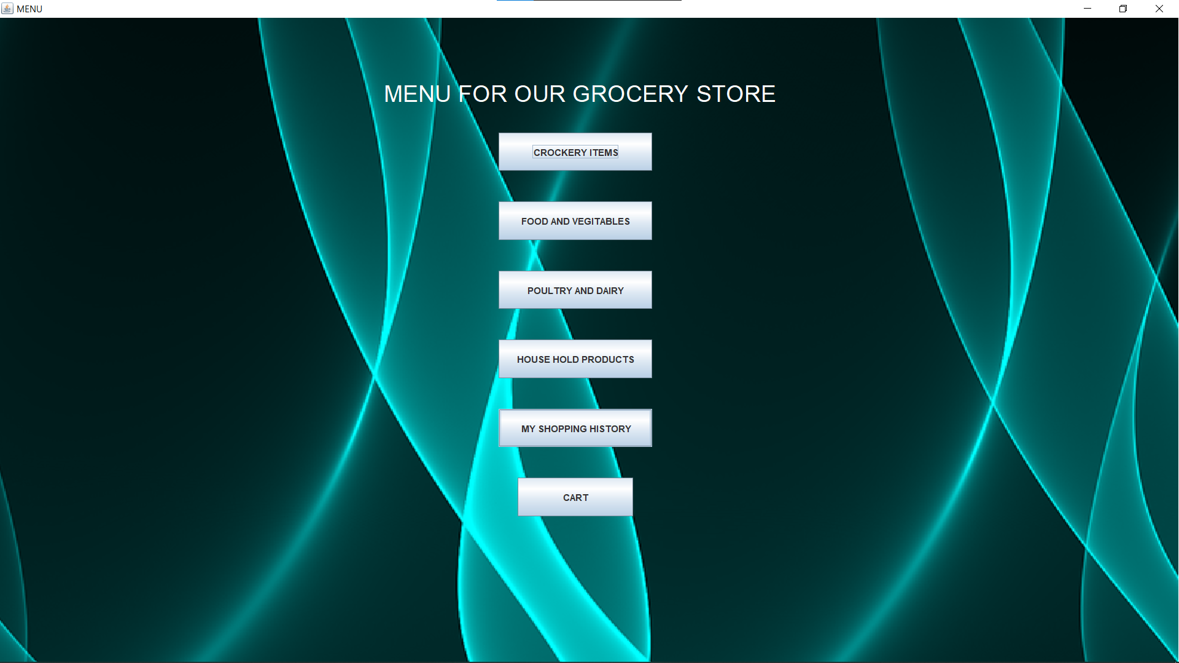

**CROCKERY ITEMS:**

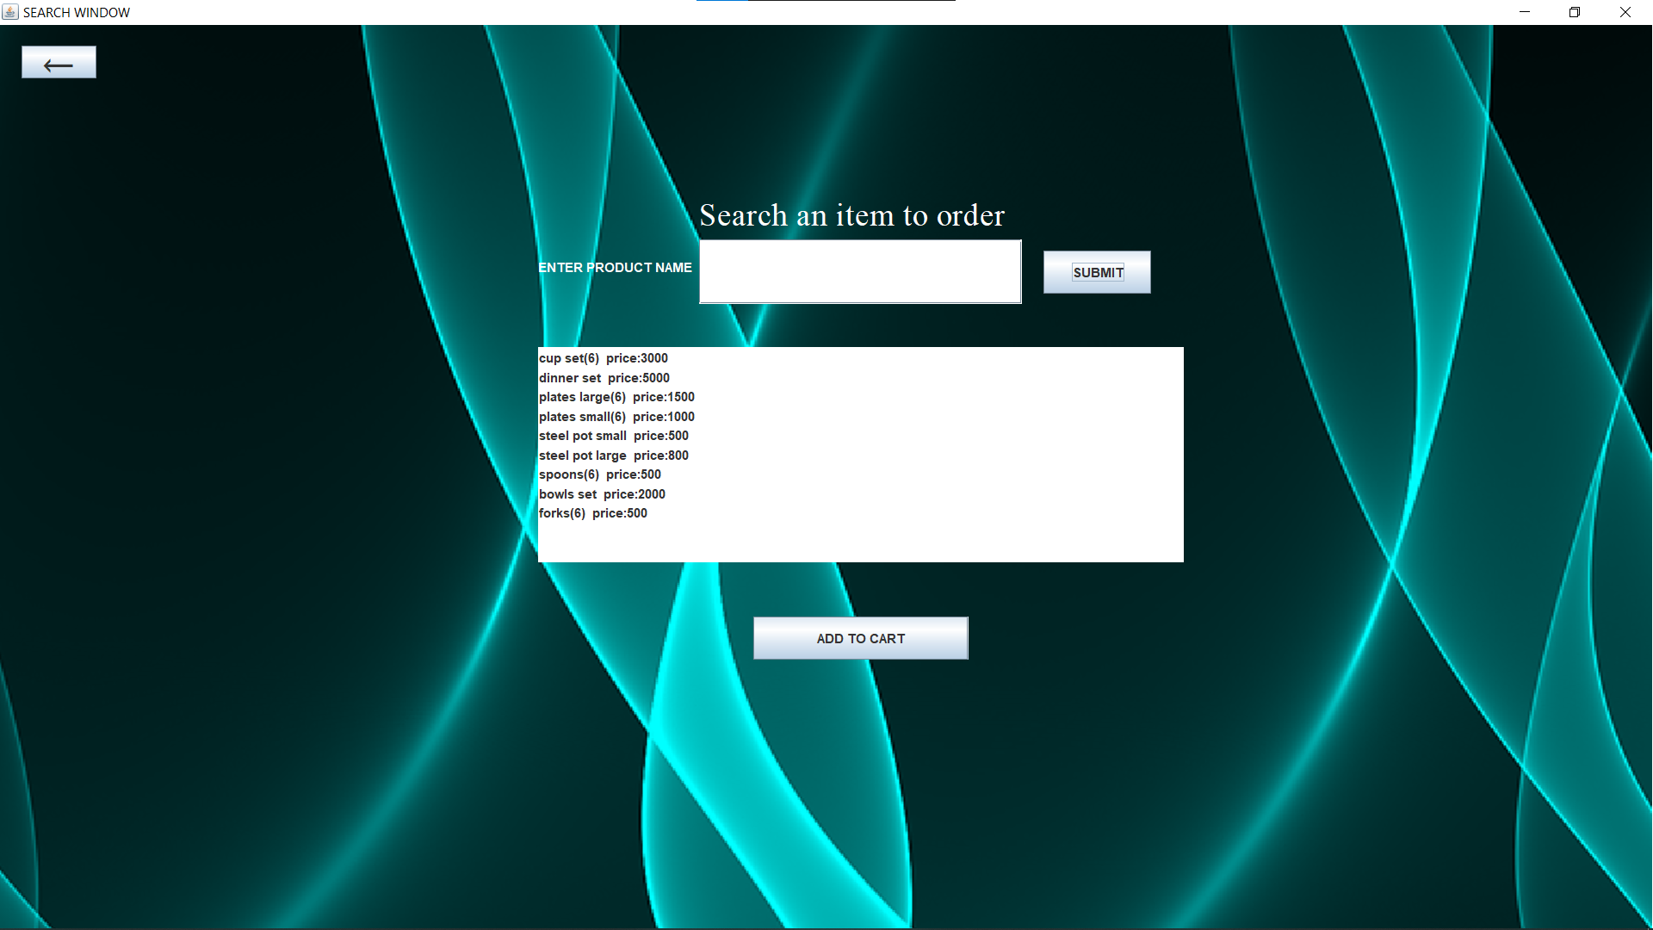

When you click on crockery items, this window opens.

It has a dynamic search option, to view all crockery items, just click submit button as demonstrated.

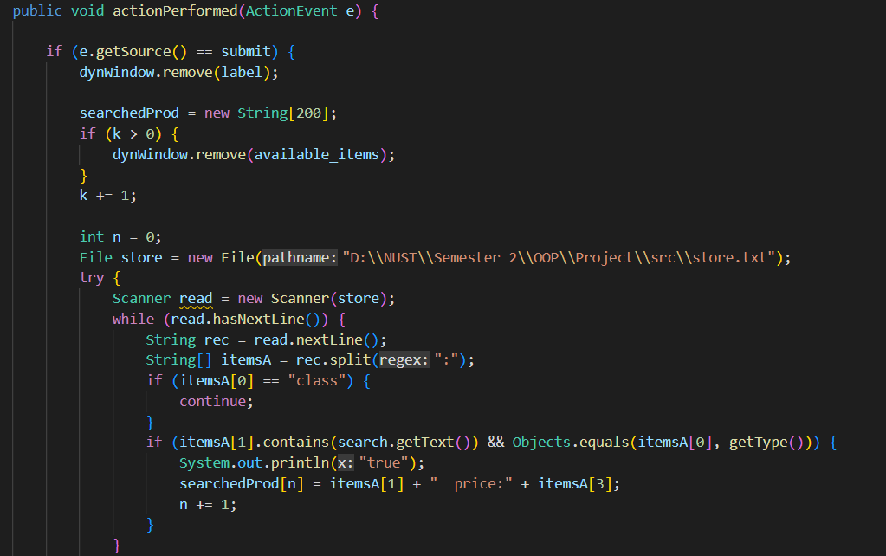

The dynamic search works in a way that it scans the inventory i.e the store file and skips the title line and moves to items in the next line. Then it matches the selected option of menu with store items and upon a match, it displays all those items.

If you write a keyword and then press submit, items against the relevant keyword will appear only.

When you select and item from the list, a view cart button appears next to add to cart, so you can access cart at any instant.

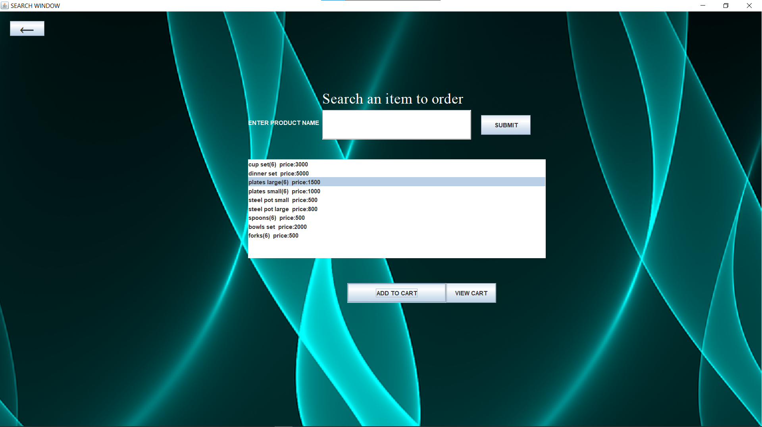

**VIEW CART**

When you click view cart, following window opens.

It has all the items that you have selected and added to cart.

If you wish to remove any product from cart, just select the product and click **remove from cart**. The product will be removed

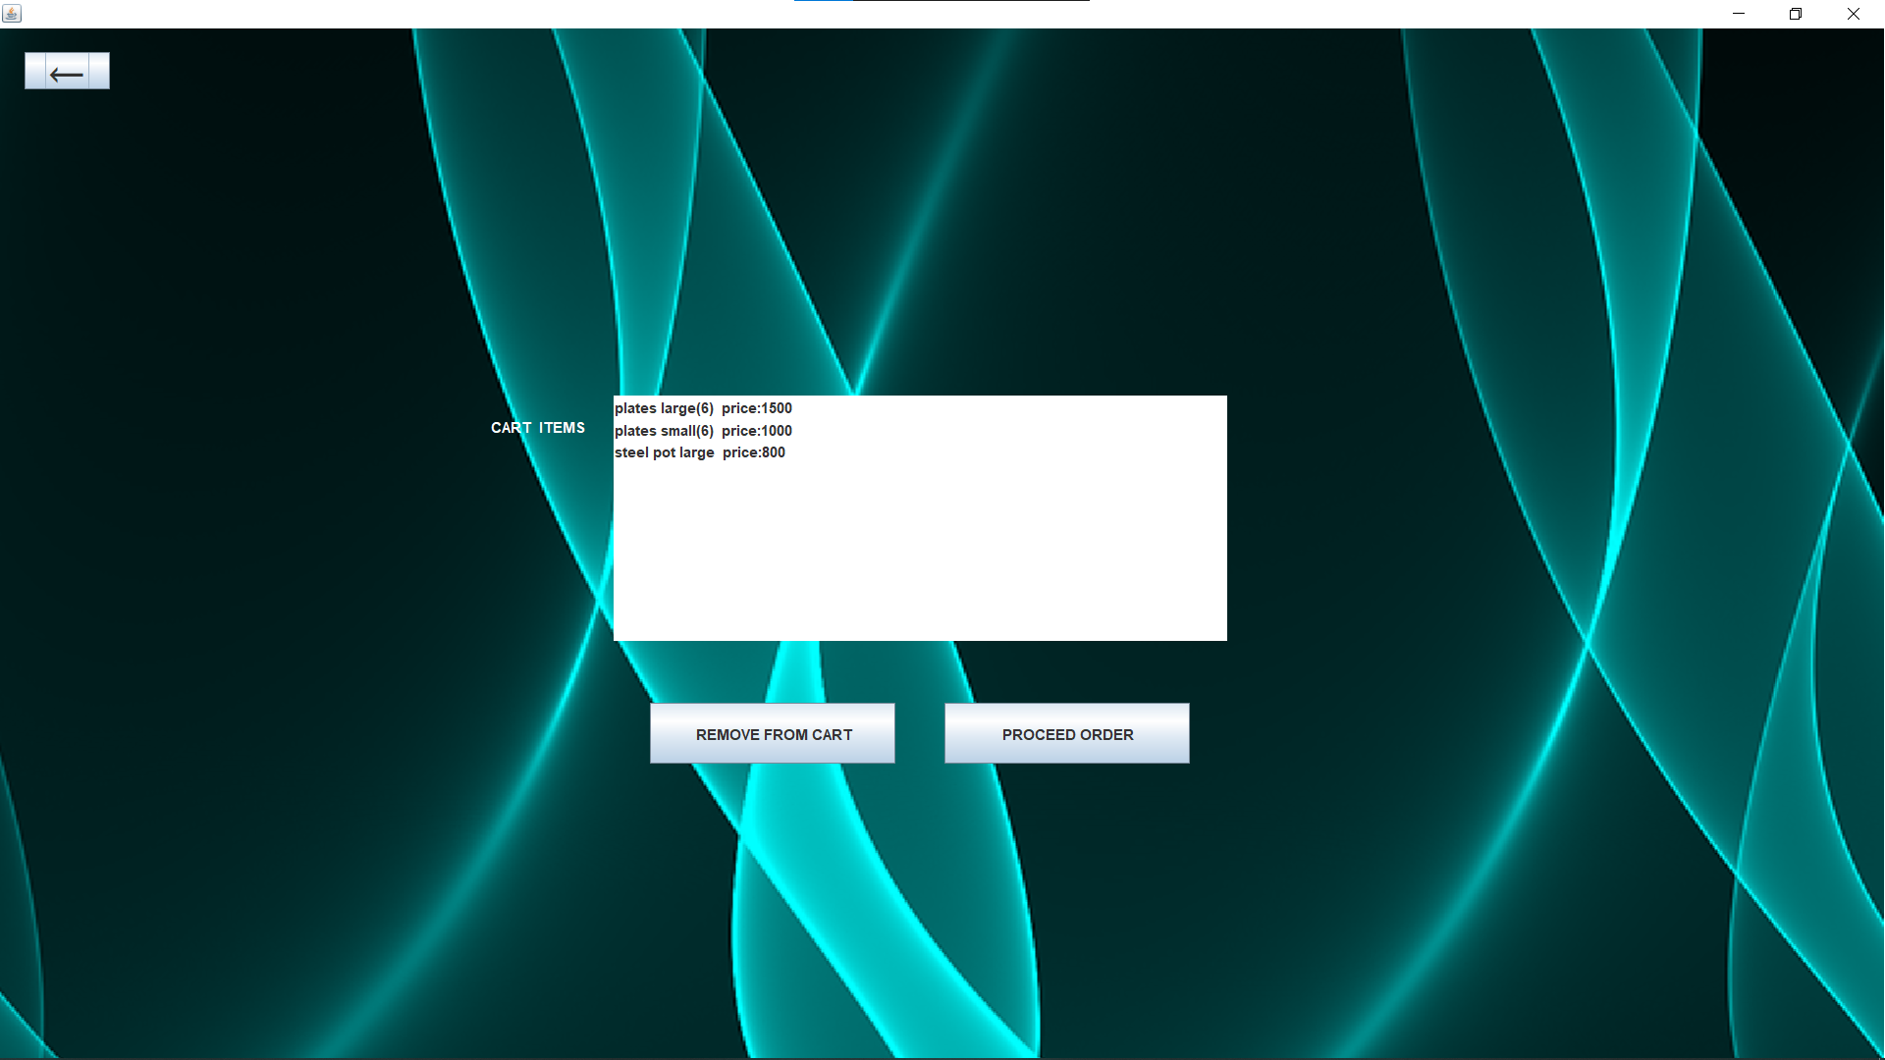

**GUI COMPONENTS FOR CART:**

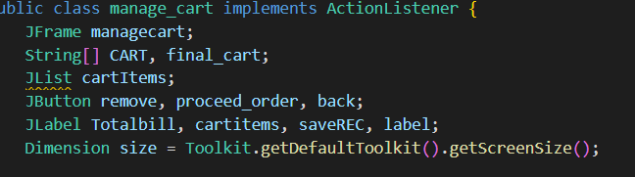

Making a String array for cart of size 200.

Opening cart file and passing cart object to be read by Scanner’s object.

Then each item in cart file is stored in item data member and then in in the cart array.

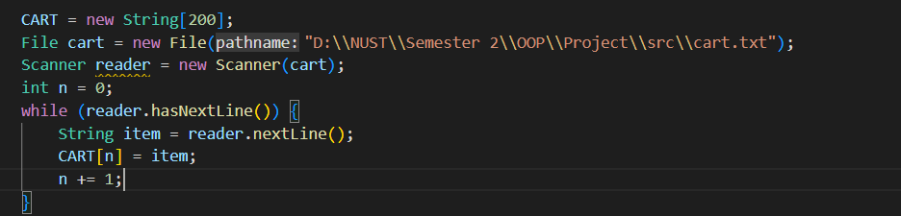

A cart array is formed. And cart file object is also created which is passed to Scanner object.The cart file is read and items of it are stored in cart array.

If user selects an item from JList i.e cartItems so, if its already in cart then ignore, otherwise add in Cart array.**

If cart array is empty then continue and if there is an item added to cart array then write the item in cart file.

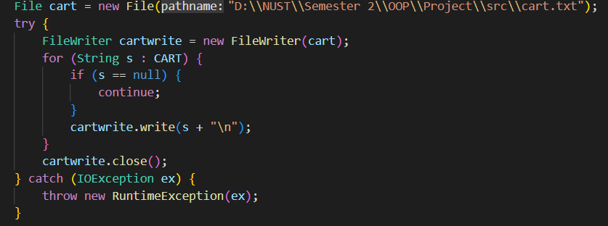

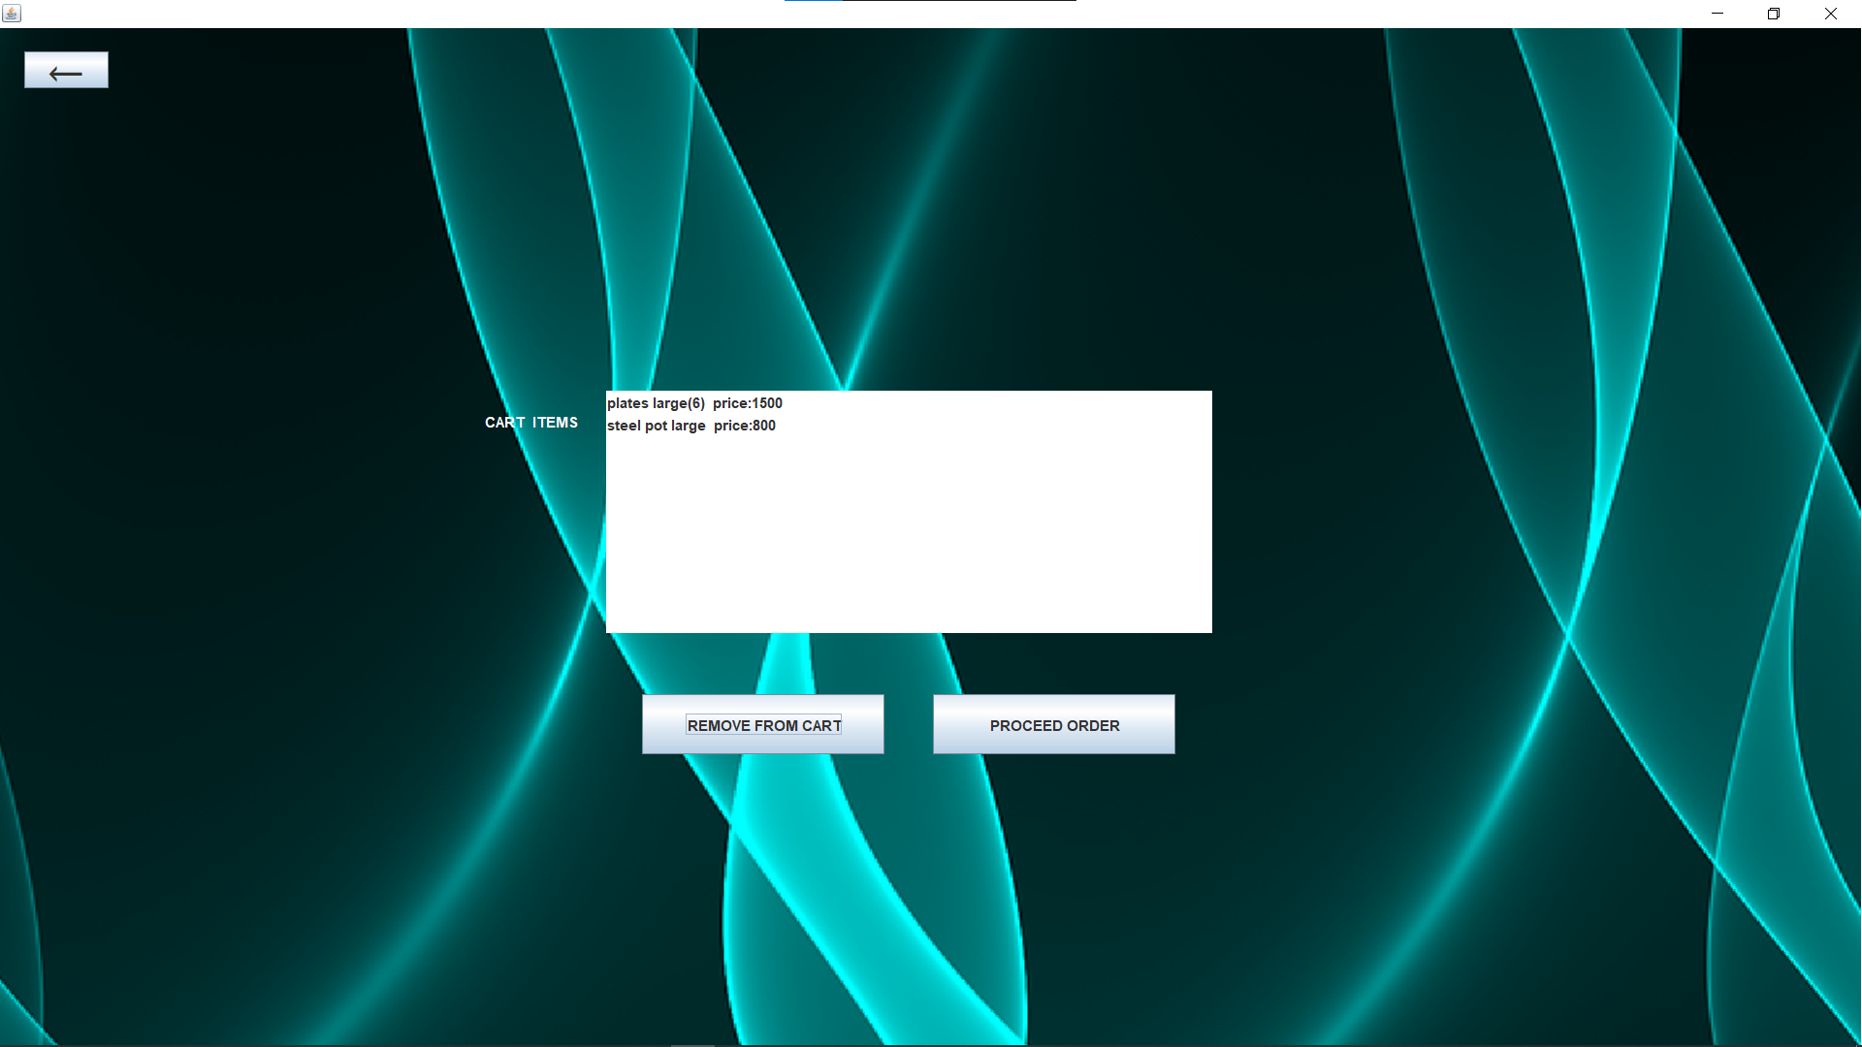

**PROCEED ORDER**

Once you have finalized your order, click proceed order to get you Bill.

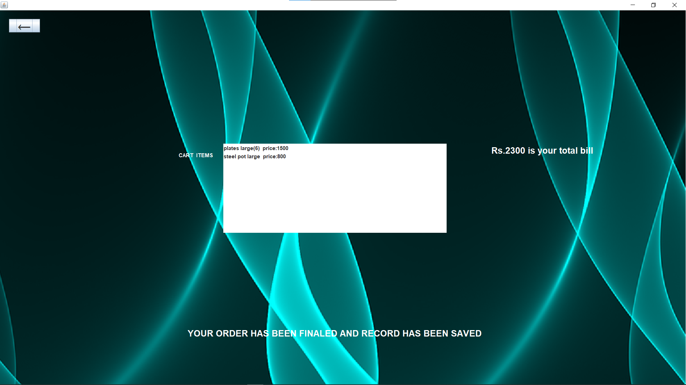

When proceed order is clicked, remove item and proceed order buttons vanish and save record label is set to visible.

Then if there is an item in a cart, its value is converted to String and then displayed.

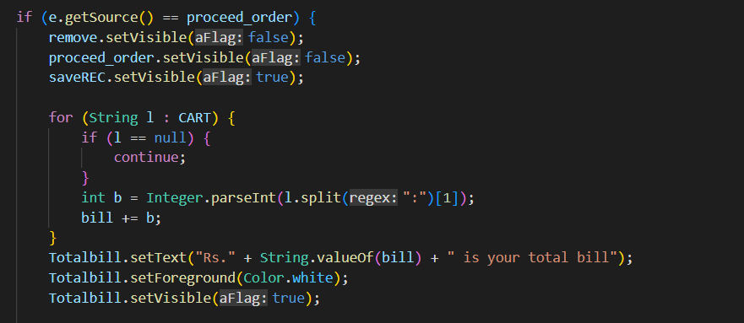

**PURCHASE HISTORY:**

If you wish to view your purchase history, head to the menu page and select **My Shopping History.**



This snippet shows our last purchase of two items.

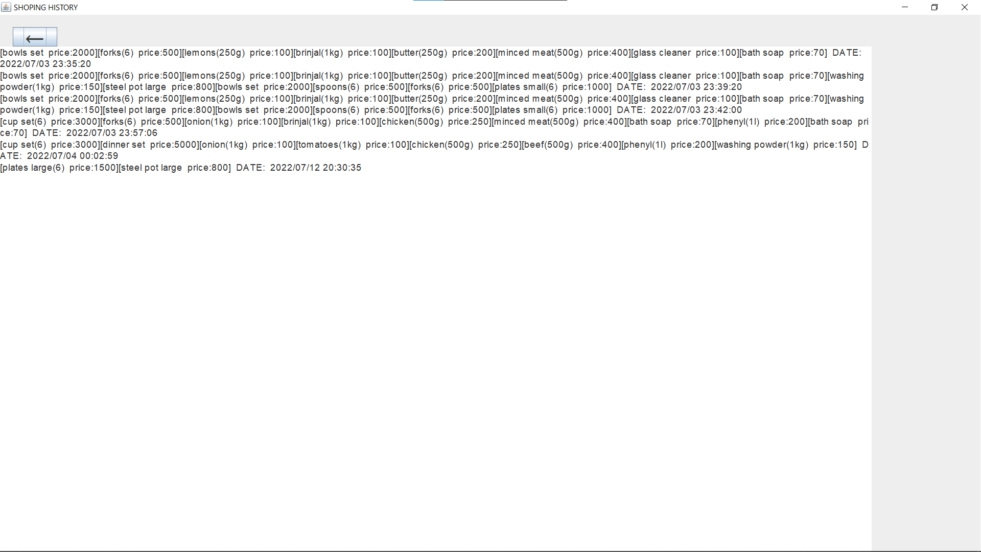

The record file is object is passed to scanner object and is read and item details are stored in a string through a loop.

Then the complete string is passed to a TextArea and displayed in History section.

